

Mathematics Specialist Unit 1

Test 3

Geometry, Combinatorics and Vectors

Name: ______________________ Total Marks:__________

Task type: Response

Time allowed for this task: 60 minutes, in-class, under test conditions
Section One: Calculator-free 20 minutes (20 marks)
Section Two: Calculator-assumed 40 minutes (40 marks)

Materials required: Calculator with CAS capability (to be provided by the student)

Standard items: Pens (blue/black preferred), pencils (including coloured), sharpener, correction fluid/tape, eraser, ruler, highlighters

Special items: Drawing instruments, templates, notes on one unfolded sheet of
A4 paper, and up to three calculators approved for use in the WACE examinations
Formula sheet

Marks available: 60 marks

Task weighting: 6%

Section One : Calculator Free Marks 20
Time Allowed 20 minutes

Question 1
[6 marks]
Consider the statement
“If a quadrilateral is a square, then it has 4 equal angles”

- Write the inverse statement.

- Write the converse statement.

- Write the contrapositive statement.

- Which of these statements are false? Give a counter example

Question 2

Determine whether or not $A⇔B$
[2 marks]
A: The two triangles are congruent.
B: The two triangles have corresponding angles equal.

Question 3
[2 marks]
A teacher gives her class of 7 students a piece of paper each and asks them to write down a permutation of the letters of the word CAR that uses all three letters once and once only.
Every student performs this correctly and the teacher collects the 7 pieces of paper. What can we conclude about the responses and why?

Question 4
[5 marks]
Using the method of proof by contradiction. Prove that if $3n+2$ is odd then $n$ is odd.

Question 5
[5 marks]

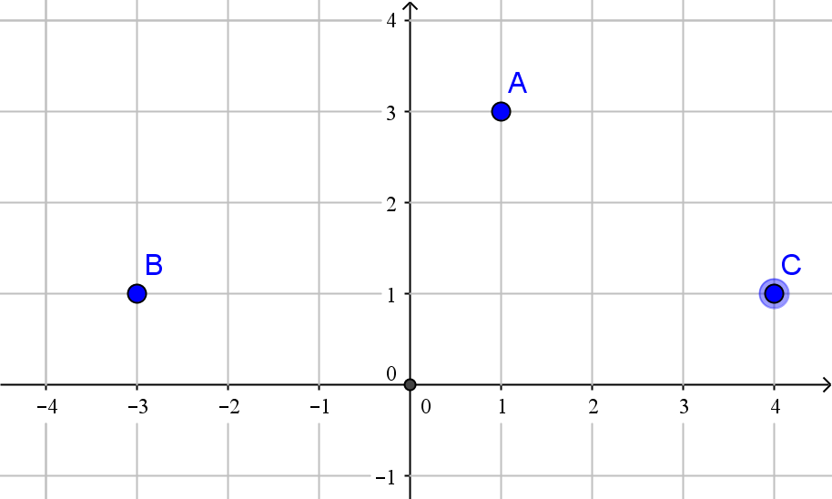

Write in the for$m ai+bj$
- The position vector of A

- The position vector of B

- The displacement of A relative to C

- The displacement of B relative to A

- The displacement of a point D relative to B is$4i-j$. What is the position vector of D

Section Two : Calculator Assumed Mark 40
Time Allowed 40 minutes Name:_______________________

Question 6
[8 marks]
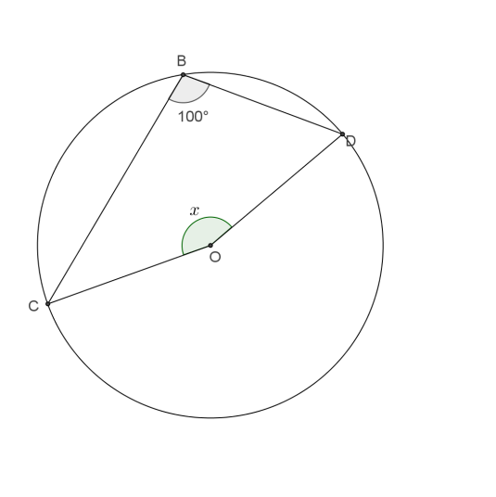
- Find the value of$x$, showing appropriate reasoning.

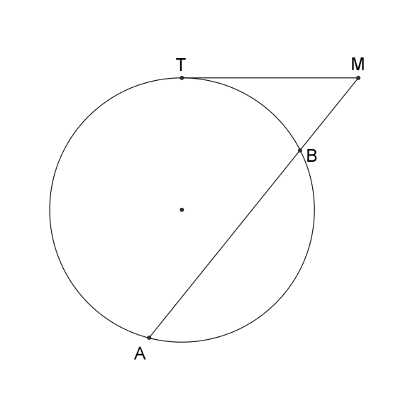
- Given that TM=6m and BM=4m. Find AB

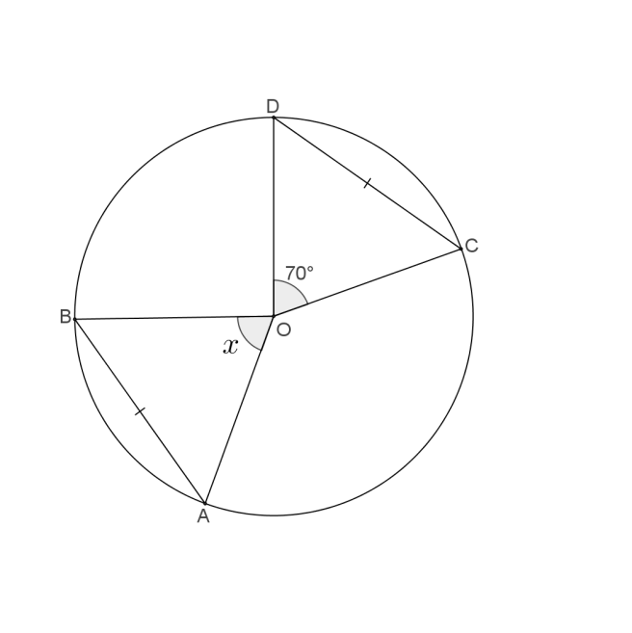
- Find the value of$x$, showing appropriate reasoning.

Question 7
[5 marks]
A boat is travelling at 20km/h on bearing of 150⁰. Relative to a person on the boat, the wind appears to come from the east with a speed of 8km/h. Find the actual speed and bearing of the wind.

Question 8
[8 marks]
A four digit code is to be chosen using the digits 0, 1, 2, 3, 4 such that no digit can be used more than once.
How many codes :

- can be formed?

- begin with 4?

- are an odd number?

- start and end in an odd number?

- are less than 400?

A code of two digits is to chosen from the digits 0, 1, 2, 3, 4 or the digits 2, 4, 6, 8.
How many two-digit codes are possible?

Question 9
[5 marks]
In the diagram below EA and EC are tangents to the curve
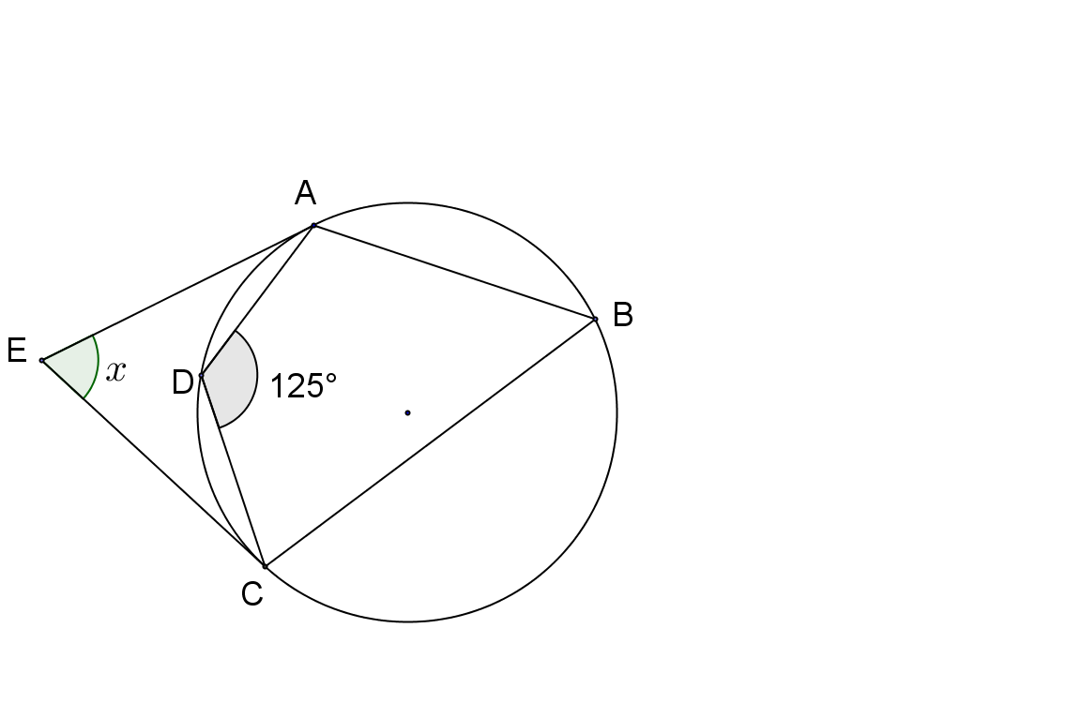
$∠AEC=x° .$Prove that $x=70$

Question 10
[6 marks]
Prove that CE is the diameter of the circle.
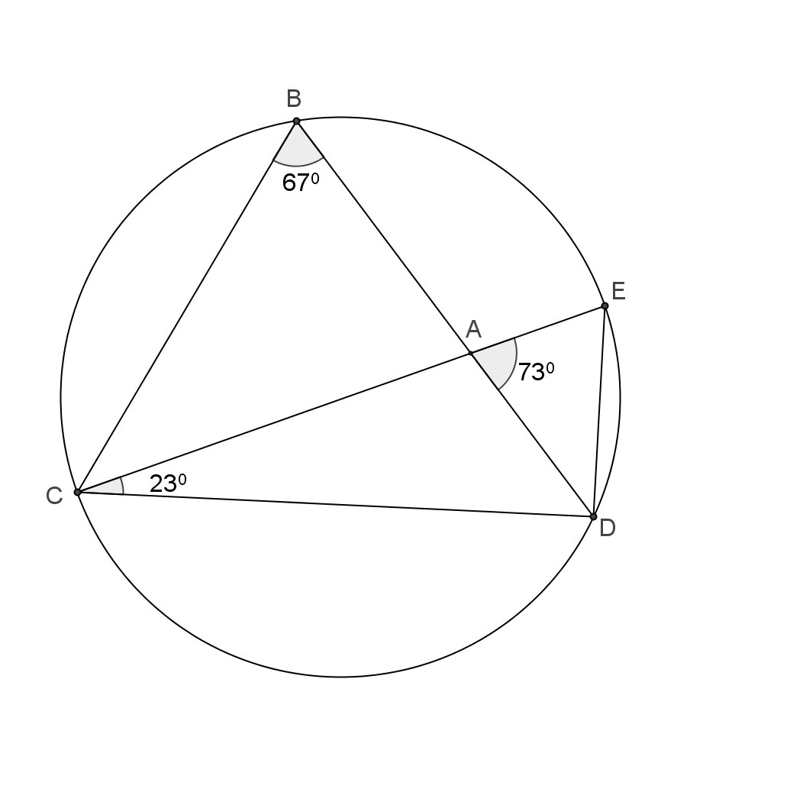

Question 11
[8 marks]
- Prove that $AB×AD=AC×AE$
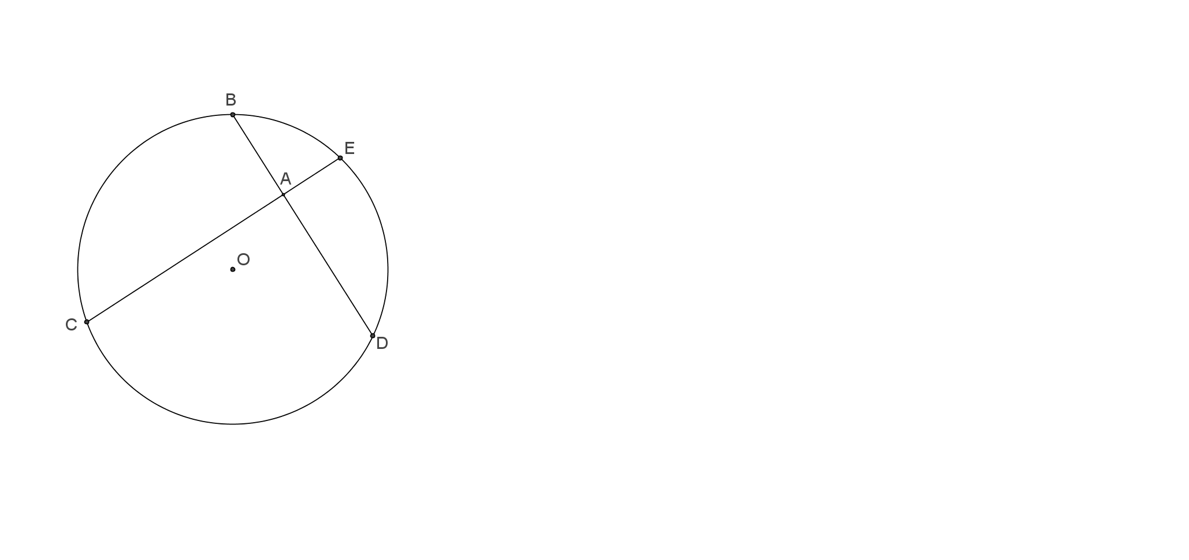

- Given that AB=4cm, AD=6cm and 2AE=AD. Find the ED.

